

Artifact Design and Test Plan

Name: Krishma Khadgi
Student Number: 2329461
Course: Bachelors (Hons) in Computer Science
University email: k.khadgi@wlv.ac.uk
Supervisor: Mohit Acharya
Date: February 2, 2025
Table of Contents
User Registration and Authentication 1
Software Requirements Specification 1
Use case diagram 3
Sequence diagram 4
Testing 5
Skills Exchange System 8
Software Requirements Specification 8
Use case diagram 9
Sequence diagram 10
Testing 11
Time Banking System 13
Software Requirements Specification 13
Use case diagram 14
Sequence diagram 15
Testing 16
Ratings and Review Management System 18
Software Requirements Specification 18
Use case diagram 19
Sequence diagram 20
Testing 21
Achievement Badges Management System 23
Software Requirements Specification 23
Use case diagram 24
Sequence diagram 25
Testing 26
Discount Management System 28
Software Requirements Specification 28
Use case diagram 29
Sequence diagram 30
Testing 31
Chat System 33
Software Requirements Specification 33
Use case diagram 34
Sequence diagram 35
Testing 36
MongoDB Schema Design Diagram 38
Gantt 39
Wireframes 39

User Registration and Authentication

Software Requirements Specification
Req. Code | Req. Description | Use Case
HRF-UR-1.0 | The platform shall allow new users to create an account with essential credentials. | User Registration
HRF-UR-1.1 | Each user account must have a unique email address. | User Registration
HRF-UR-1.2 | Passwords must adhere to security standards. | User Registration
HRF-UR-1.3 | The platform should require users to confirm their password during registration. | User Registration
HRF-UR-1.4 | The must validate all the required registration fields. | User Registration
HRF-UR-1.5 | User credentials should be stored in a database securely. | User Registration
HRF-UR-1.6 | A verification email should be sent upon registration to confirm account ownership. | User Registration
HRF-UR-1.7 | Users shall receive real-time error messages for invalid input during registration. | User Registration
HRF-UR-1.8 | User login should be possible using their registered email and password. | User Login
HRF-UR-1.9 | The platform should verify login credentials against stored data. | User Login
HRF-UR-1.10 | Secure authentication methods like JSON Web token should be used to prevent unauthorized access. | User Login
HRF-UR-1.11 | Important data like password must be stored after encryption. | User Login
HRF-UR-1.12 | Upon successful login, the system shall initiate a user session. | User Login
HRF-UR-1.13 | Users shall be redirected to their dashboard after logging in. | User Login
HRF-UR-1.14 | The platform should allow users to log out securely. | User Logout
HRF-UR-1.15 | User sessions shall be invalidated upon logout. | User Logout
HRF-UR-1.16 | If login fails due to incorrect credentials, an appropriate error message shall be displayed. | User Login
HRF-UR-1.17 | The system shall provide a password reset mechanism. | Password Reset
HRF-UR -1.18 | User authentication and authorization mechanisms shall be designed to protect against security threats. | Security
HRF-UR -1.19 | Passwords and authentication tokens shall never be stored in plaintext. | Security
HRF-UR -1.20 | The platform should respond to user requests. | General
HRF-UR 1.21 | The system shall provide visual feedback when processing user requests. | User Experience
HRF-UR 1.22 | The platform should be fully responsive. | User Experience
HRF-UR 1.23 | The system shall allow users to edit their profile information, including skills offered, availability, and location. | Profile Management
HRF-UR 1.24 | The system shall display user profiles with relevant information (skills, availability, ratings, etc.). | Profile Management

Use case diagram
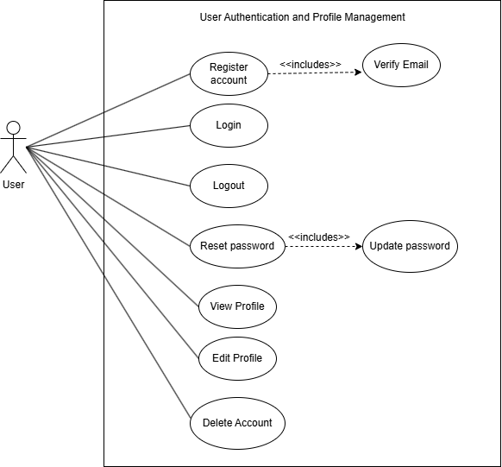
Use case diagram for User Authentication 1

Sequence diagram
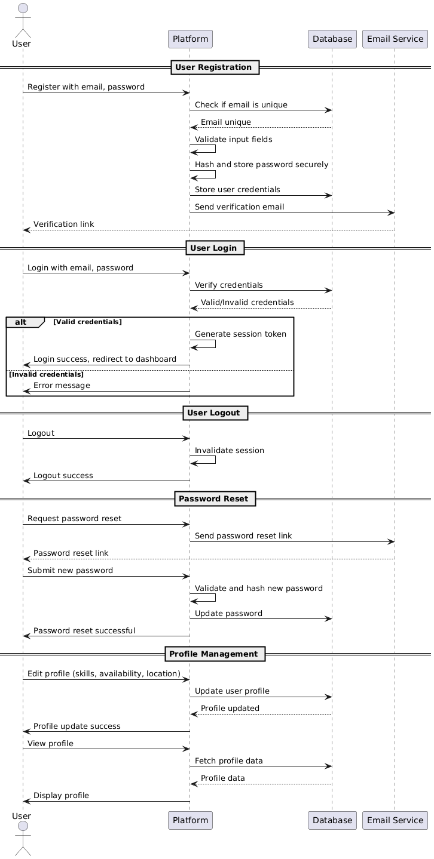
Sequence diagram for User Authentication 1

Testing
Req. Code | Req. Description | Test ID | Test Case Description | Expected Result | Status
UM-F-1.0 | The platform shall allow new users to create an account with essential credentials. | TC-001 | Verify that a new user can successfully create an account with required credentials | User should be able to create an account successfully | Success
UM-F-1.1 | Each user account must have a unique email address. | TC-002 | Ensure that a duplicate email address cannot be used for registration | System should reject duplicate email addresses | Success
UM-F-1.2 | Passwords must adhere to security standards. | TC-003 | Validate password strength requirements (e.g. minimum length, special characters) | System should enforce password security rules | Success
UM-F-1.3 | The platform should require users to confirm their password during registration. | TC-004 | Check if users must re-enter and match their password before proceeding | Passwords must match for registration to succeed | Success
UM-F-1.4 | The system must validate all the required registration fields. | TC-005 | Verify that registration fails if required fields are missing | System should display appropriate error messages | Success
UM-F-1.5 | User credentials should be stored in a database securely. | TC-006 | Confirm that passwords are not stored in plaintext and use encryption | Passwords should be securely hashed | Success
UM-F-1.6 | A verification email should be sent upon registration to confirm account ownership. | TC-007 | Ensure that a verification email is sent after successful registration | User should receive a verification email | Success
UM-F-1.7 | Users shall receive real-time error messages for invalid input during registration. | TC-008 | Check if invalid inputs display error messages in real time | System should provide immediate feedback | Success
UM-F-1.8 | User login should be possible using their registered email and password. | TC-009 | Verify that users can log in with correct credentials | User should be able to log in successfully | Success
UM-F-1.9 | The platform should verify login credentials against stored data. | TC-010 | Ensure the system correctly validates login credentials | Invalid credentials should be rejected | Success
UM-F-1.10 | Secure authentication methods like JSON Web Token should be used to prevent unauthorized access. | TC-011 | Verify that JWT is issued upon successful login | JWT should be generated and used for authentication | Success
UM-NF-1.11 | Important data like passwords must be stored after encryption. | TC-012 | Confirm that sensitive data is encrypted in storage | Data should not be stored in plaintext | Success
UM-F-1.12 | Upon successful login the system shall initiate a user session. | TC-013 | Verify that a user session starts after login | System should create a session for authenticated users | Success
UM-F-1.13 | Users shall be redirected to their dashboard after logging in. | TC-014 | Check if users are redirected to their dashboard post-login | User should land on the dashboard | Success
UM-F-1.14 | The platform should allow users to log out securely. | TC-015 | Ensure that users can log out successfully | User should be logged out and redirected appropriately | Success
UM-F-1.15 | User sessions shall be invalidated upon logout. | TC-016 | Confirm that user sessions are terminated after logout | Session should be invalidated upon logout | Success
UM-F-1.16 | If login fails due to incorrect credentials, an appropriate error message shall be displayed. | TC-017 | Verify that incorrect login attempts show a relevant error message | User should see a meaningful error message | Success
UM-F-1.17 | The system shall provide a password reset mechanism. | TC-018 | Ensure users can reset passwords via email | Users should receive password reset instructions | Success
UM-NF-1.18 | User authentication and authorization mechanisms shall be designed to protect against security threats. | TC-019 | Test if authentication mechanisms are resilient against common attacks | System should prevent unauthorized access | Success
UM-NF-1.19 | Passwords and authentication tokens shall never be stored in plaintext. | TC-020 | Confirm that passwords and tokens are securely stored | Passwords/tokens should be encrypted | Success
UM-F-1.20 | The platform should respond to user requests. | TC-021 | Verify if the platform provides responses to various user requests | System should respond appropriately | Success
UM-UR-1.21 | The system shall provide visual feedback when processing user requests. | TC-022 | Check if visual indicators (e.g. loading spinners) appear during processing | Users should see feedback during operations | Success
UM-UR-1.22 | The platform should be fully responsive. | TC-023 | Ensure the platform adapts well to different screen sizes | System should be usable on all device types | Pending
UM-F-1.23 | The system shall allow users to edit their profile information including skills offered, availability, and location. | TC-024 | Verify that users can update their profile details | Users should be able to save edited profiles | Success
UM-F-1.24 | The system shall display user profiles with relevant information (skills, availability, ratings, etc.). | TC-025 | Ensure that user profiles display accurate and relevant information | Profiles should show correct user details | Success

Skills Exchange System

Software Requirements Specification:
Req. Code | Req. Description | Use Case
HRF-SE- 1.0 | Users shall be able to post a service request based on their needs. | Service Request
HRF-SE- 1.1 | The system shall allow users to search for available services based on their location and skill type. | Service Exchange
HRF-SE- 1.2 | The system shall allow users to request services from others. | Service Exchange
HRF-SE- 1.3 | The system shall allow users to offer their services to others. | Service Exchange
HRF-SE- 1.4 | The system shall use Geolocation API to capture the user’s live location for service matching. | Service Matching
HRF-SE- 1.5 | The system shall create a skills profile for each user based on the extracted and categorized skills. | Service Exchange
HRF-SE- 1.6 | The system shall filter services based on the user's location and search radius. | Service Exchange
HRF-SE- 1.7 | Each service shall have a time-based value | Service Exchange
HRF-SE- 1.8 | Users shall be able to schedule service exchanges. | Service Scheduling
HRF-SE- 1.9 | After service completion, the service request should be automatically removed from the “Services” page. | Service Deletion

Use case diagram
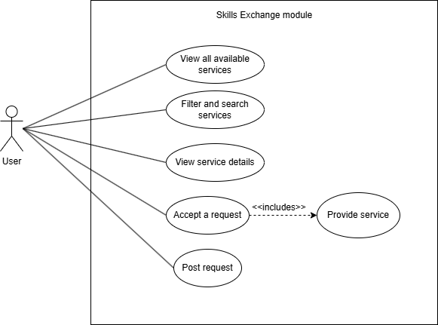
Use case diagram for Service Exchange 1

Sequence diagram
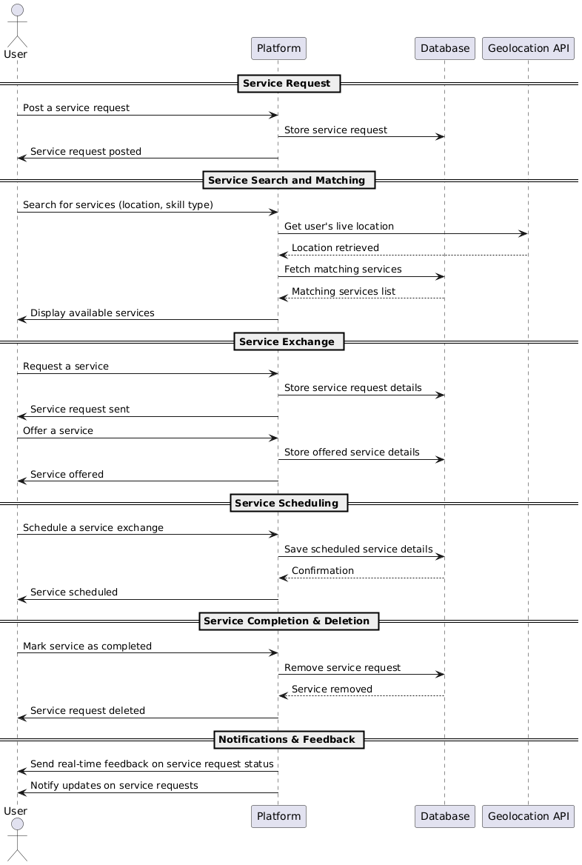
Sequence diagram for Service Exchange 1

Testing
Req. Code | Req. Description | Test ID | Test Case Description | Expected Result | Status
SES-F-1.0 | Users shall be able to post a service request based on their needs. | TC-001 | Verify that users can successfully post a service request based on their needs | User should be able to post a service request | Success
SES-F-1.1 | The system shall allow users to search for available services based on their location and skill type. | TC-002 | Ensure users can search for services based on location and skill type | User should see relevant service results based on search parameters | Success
SES-F-1.2 | The system shall allow users to request services from others. | TC-003 | Check if users can request services from others | User should be able to request services | Success
SES-F-1.3 | The system shall allow users to offer their services to others. | TC-004 | Verify that users can offer services to others | User should be able to offer services | Success
SES-F-1.4 | The system shall use the Geolocation API to capture the user’s live location for service matching. | TC-005 | Confirm if the system captures the user’s location using the Geolocation API | User’s live location should be captured and used for service matching | Success
SES-F-1.5 | The system shall create a skills profile for each user based on the extracted and categorized skills. | TC-006 | Ensure the system creates a skills profile for each user | A profile should be created with categorized skills | Success
SES-F-1.6 | The system shall filter services based on the user's location and search radius. | TC-007 | Check if services are filtered by location and search radius | Services should be displayed according to location and radius | Pending
SES-F-1.7 | Each service shall have a time-based value. | TC-008 | Verify if each service has a time-based value | Services should have a time-based value | Success
SES-F-1.8 | Users shall be able to schedule service exchanges. | TC-009 | Ensure users can schedule a service exchange | Users should be able to select a time for service exchanges | Success
SES-F-1.9 | After service completion, the service request should be automatically removed from the 'Services' page. | TC-010 | Check if service requests are removed after completion | Service requests should disappear from the page after completion | Success
SES-NF-1.10 | The system shall ensure data security and privacy for all users. | TC-011 | Verify that user data is secure and privacy is maintained | User data should be secure and private | Success
SES-NF-1.11 | The system shall be available with 99.9% uptime for reliability. | TC-012 | Test system availability and uptime | System should have 99.9% uptime | Success
SES-NF-1.12 | Service matching algorithms shall process requests within 2 seconds. | TC-013 | Ensure service matching requests are processed within 2 seconds | Requests should be processed within 2 seconds | Success
SES-NF-1.13 | The system shall encrypt all personal user data in transit and at rest. | TC-014 | Verify that personal data is encrypted in transit and at rest | Data should be encrypted both during transit and while stored | Success
SES-UR-1.14 | The platform shall provide a user-friendly interface for browsing and posting service requests. | TC-015 | Ensure the platform has an intuitive and user-friendly interface | Interface should be easy to navigate and use | Success
SES-UR-1.15 | The system shall provide real-time feedback on service request status. | TC-016 | Check if the system provides real-time status updates for service requests | Users should see real-time feedback on request status | Success
SES-UR-1.16 | Users shall receive clear notifications for service request updates. | TC-017 | Ensure that users receive notifications for service request updates | Users should receive timely and clear notifications | Pending
SES-UR-1.17 | The system shall support responsive design for mobile, tablet, and desktop users. | TC-018 | Check if the system is responsive on mobile, tablet, and desktop devices | The platform should adapt to all device types | Pending

Time Banking System

Software Requirements Specification:
Req. Code | Req. Description | Use Case
HRF-TB- 1.0 | The system shall allow users to send time credits after receiving services. | Time Banking
HRF-TB- 1.1 | The system should dynamically update the service provider’s time credits after clients send the amount. | Time Banking
HRF-TB- 1.2 | The system shall track each user's time hours and update it in real-time. | Time Banking
HRF-TB- 1.3 | The system shall display the user's current time balance on their profile. | Time Banking
HRF-TB- 1.4 | The users should be allowed to view their recent transactions. | Time Banking
HRF-TB- 1.5 | The system should be secure in handling transactions so that no blunder occurs. | Security

Use case diagram

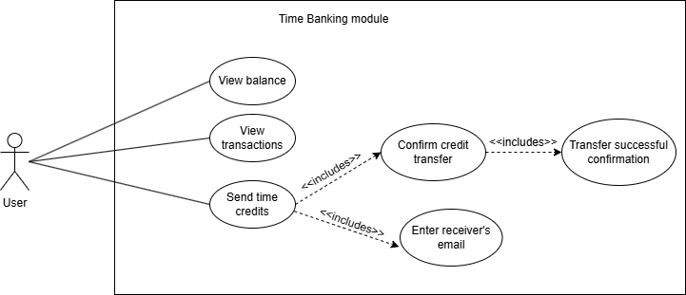
Use case diagram for Time Banking 1

Sequence diagram
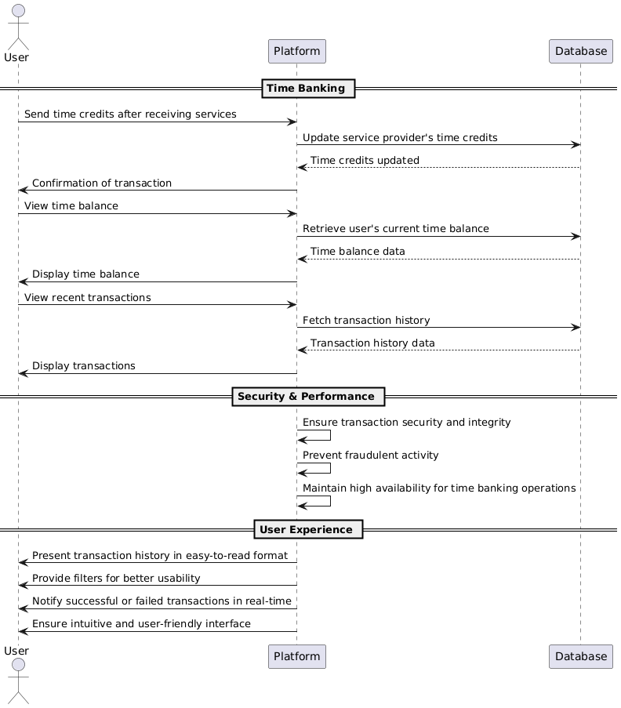
Sequence diagram for Time Banking 1

Testing
Req. Code | Req. Description | Test ID | Test Case Description | Expected Result | Status
TBS-F-1.0 | The system shall allow users to send time credits after receiving services. | TC-001 | Verify that users can send time credits after receiving services | Users should be able to send time credits after services | Success
TBS-F-1.1 | The system should dynamically update the service provider’s time credits after clients send the amount. | TC-002 | Ensure that the service provider’s time credits are updated dynamically | Time credits should be updated in real-time for service provider | Success
TBS-F-1.2 | The system shall track each user's time hours and update it in real-time. | TC-003 | Verify that the system tracks and updates each user’s time hours in real-time | Time hours should be tracked and updated instantly | Success
TBS-F-1.3 | The system shall display the user's current time balance on their profile. | TC-004 | Ensure that the user’s time balance is displayed on their profile | Time balance should be visible on the user profile | Success
TBS-F-1.4 | The users should be allowed to view their recent transactions. | TC-005 | Verify that users can view their recent transactions | Recent transactions should be accessible to users | Success
TBS-NF-1.5 | The system should be secure in handling transactions so that no blunder occurs. | TC-006 | Check if the system securely handles transactions without errors | Transactions should be securely processed without errors | Success
TBS-NF-1.6 | The system shall ensure transaction integrity and prevent fraudulent activity. | TC-007 | Ensure that the system prevents fraudulent activities and maintains transaction integrity | Transactions should be secure and fraud-free | Success
TBS-NF-1.7 | The system should support high availability to ensure seamless time banking operations. | TC-008 | Test the system’s availability and performance during high traffic | The system should maintain high availability during heavy usage | Success
TBS-UR-1.8 | The transaction history shall be presented in an easy-to-read format with filters for better usability. | TC-009 | Ensure the transaction history is readable with available filters | Transaction history should be easy to read and filterable | Pending
TBS-UR-1.9 | Users shall receive real-time notifications for successful and failed transactions. | TC-010 | Verify that users receive notifications for both successful and failed transactions | Users should get real-time notifications for transaction outcomes | Success
TBS-UR-1.10 | The interface for sending and receiving time credits should be intuitive and user-friendly. | TC-011 | Check if the interface for sending and receiving time credits is user-friendly | The interface should be intuitive and easy to use | Success

Ratings and Review Management System

Software Requirements Specification:
Req. Code | Req. Description | Use Case
HRF-RR- 1.0 | The system shall allow clients to rate and review individuals after service exchanges. | Ratings and Reviews
HRF-RR- 1.1 | The users can be rated on a scale of 1-5. | Ratings and Reviews
HRF-RR- 1.2 | The system shall calculate each user’s average rating. | Ratings calculation
HRF-RR- 1.3 | The average rating should be dynamically updated on user profiles | Ratings display
HRF-RR- 1.4 | The system shall display individual reviews on user profiles. | Reviews display
HRF-RR- 1.5 | The system shall display the reviewer's name or alias with each review. | Ratings and Reviews
HRF-RR- 1.6 | The system shall display reviews in chronological order (most recent first). | Ratings and Reviews

Use case diagram
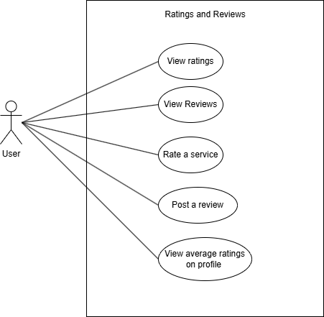
Use case diagram for Ratings and Reviews 1

Sequence diagram
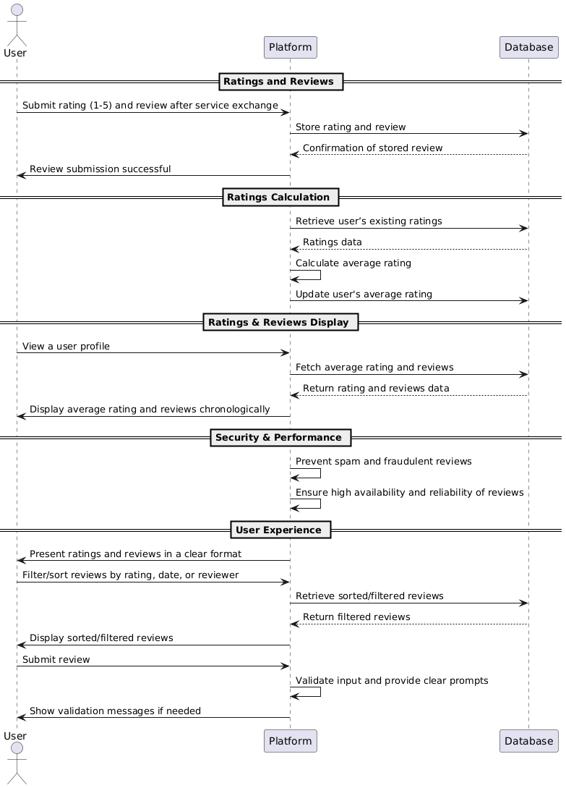
Sequence diagram for Ratings and Reviews 1

Testing
Req. Code | Req. Description | Test ID | Test Case Description | Expected Result | Status
RMS-F-1.0 | The system shall allow clients to rate and review individuals after service exchanges. | TC-001 | Verify that clients can rate and review individuals after service exchanges | Clients should be able to rate and review after completing service exchanges | Success
RMS-F-1.1 | The users can be rated on a scale of 1-5. | TC-002 | Ensure that users can be rated on a scale from 1 to 5 | Users should be able to select a rating from 1 to 5 | Success
RMS-F-1.2 | The system shall calculate each user’s average rating. | TC-003 | Verify that the system calculates each user’s average rating correctly | Average rating should be accurately calculated based on ratings | Success
RMS-F-1.3 | The average rating should be dynamically updated on user profiles. | TC-004 | Ensure that the average rating is updated in real-time on user profiles | Average rating should update immediately after a new rating | Success
RMS-F-1.4 | The system shall display individual reviews on user profiles. | TC-005 | Verify that individual reviews are displayed on user profiles | Each review should be visible on the user’s profile | Success
RMS-F-1.5 | The system shall display the reviewer's name or alias with each review. | TC-006 | Ensure that each review displays the reviewer’s name or alias | Reviewer’s name or alias should appear with their review | Success
RMS-F-1.6 | The system shall display reviews in chronological order (most recent first). | TC-007 | Ensure reviews are shown in chronological order, with the most recent review displayed first | Reviews should appear in order with most recent at the top | Success
RMS-NF-1.7 | The rating system shall be designed to prevent spam or fraudulent reviews. | TC-008 | Verify that the rating system prevents spam or fraudulent reviews | The system should block fraudulent or spam reviews | Success
RMS-NF-1.8 | The system should ensure high availability and reliability of the rating and review feature. | TC-009 | Test if the rating and review feature works during high traffic | The rating and review feature should function smoothly during peak traffic | Success
RMS-UR-1.9 | The ratings and reviews should be presented in a clear and readable format. | TC-010 | Ensure that ratings and reviews are displayed in a readable format | Ratings and reviews should be easy to read and understand | Success
RMS-UR-1.10 | Users shall be able to filter and sort reviews based on rating, date, or reviewer. | TC-011 | Verify that users can filter and sort reviews by rating, date, or reviewer | Users should be able to filter and sort reviews by specified parameters | Pending
RMS-UR-1.11 | The review submission process should be user-friendly with clear prompts and validation messages. | TC-012 | Check if the review submission process is user-friendly with prompts and validation | The review submission should be easy to complete with helpful prompts | Success

Achievement Badges Management System

Software Requirements Specification:
Req. Code | Req. Description | Use Case
HRF-AB- 1.0 | The system shall track eligibility for achievement badges based on predefined standards. | Achievement Badges
HRF-AB- 1.1 | The system shall dynamically award achievement badges to users based on specific criteria (e.g., completing a certain number of service hours). | Achievement Badges Creation
HRF-AB- 1.2 | The system shall display earned badges on user profiles. | Recognition
HRF-AB- 1.3 | The system shall allow users to view detailed information about each badge (e.g., description, criteria to earn it). | Achievement Badges
HRF-AB- 1.4 | The system shall notify users when they earn a new badge. | Achievement Badges

Use case diagram

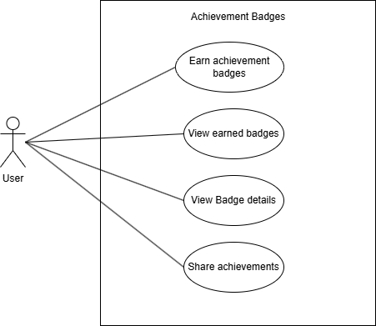
Use case diagram for Achievement Badges 1

Sequence diagram
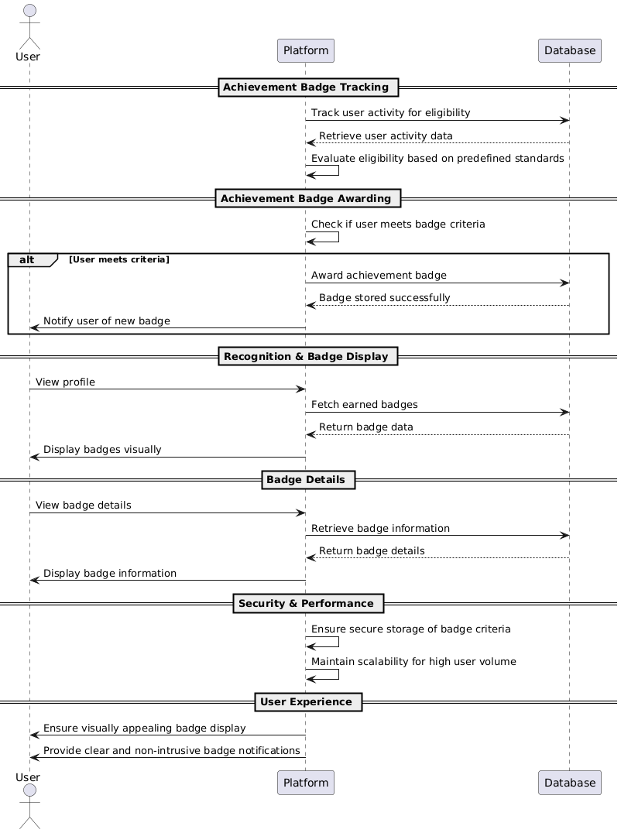
Sequence diagram for Achievement Badges 1

Testing
Req. Code | Req. Description | Test ID | Test Case Description | Expected Result | Status
AMS-F-1.0 | The system shall track eligibility for achievement badges based on predefined standards. | TC-001 | Verify that the system tracks eligibility for achievement badges based on standards | System should track eligibility correctly based on the predefined criteria | Pending
AMS-F-1.1 | The system shall dynamically award achievement badges to users based on specific criteria (e.g., completing a certain number of service hours). | TC-002 | Ensure that achievement badges are awarded dynamically based on specific criteria | Badges should be awarded automatically when criteria are met | Pending
AMS-F-1.2 | The system shall display earned badges on user profiles. | TC-003 | Verify that earned badges are displayed on user profiles | Earned badges should be visible on user profiles | Pending
AMS-F-1.3 | The system shall allow users to view detailed information about each badge (e.g., description, criteria to earn it). | TC-004 | Ensure users can view detailed information about each badge | Users should be able to view the description and criteria for each badge | Pending
AMS-F-1.4 | The system shall notify users when they earn a new badge. | TC-005 | Verify that users are notified when they earn a new badge | Users should receive a notification when a new badge is earned | Pending
AMS-NF-1.5 | The badge assignment process should be automated and scalable for high user volume. | TC-006 | Ensure the badge assignment process is automated and scalable | System should handle a high volume of users without performance issues | Pending
AMS-NF-1.6 | The system should ensure that badge criteria are securely stored and cannot be tampered with. | TC-007 | Verify that badge criteria are securely stored and protected | Badge criteria should be securely stored and tamper-proof | Pending
AMS-UR-1.7 | The badge display should be visually appealing and easy to understand. | TC-008 | Check that the badge display is visually appealing and easy to understand | Badges should have a clear attractive design | Pending
AMS-UR-1.8 | Users should be able to sort and filter badges in their profile. | TC-009 | Ensure users can sort and filter badges in their profile | Users should be able to filter and sort badges by relevant criteria | Pending
AMS-UR-1.9 | Notifications about new badges should be clear and non-intrusive. | TC-010 | Verify that badge notifications are clear and non-intrusive | Notifications should be clear and not disrupt the user experience | Pending

Discount Management System

Software Requirements Specification:
Req. Code | Req. Description | Use Case
HRF-DP- 1.0 | The users should be able to view all the available discounts on “discounts” page. | Discounts display
HRF-DP- 1.1 | The users shall be able to preview discounts information. | Discounts and Promotions
HRF-DP- 1.2 | Users should be allowed to accept the discounts and offers. | Discounts and Promotions
HRF-DP- 1.3 | The system shall provide discounts at partner businesses based on the user's time hours. | Discounts and Promotions
HRF-DP- 1.4 | The system shall track eligibility for discounts based on time hours. | Discounts and Promotions
HRF-DP- 1.5 | A prompt should be given if the user does not have sufficient time credits. | Discounts and Promotions

Use case diagram
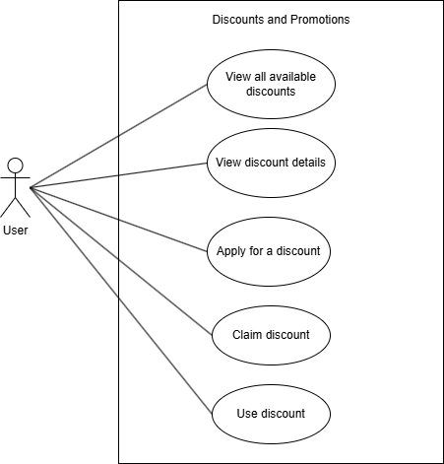

Use case diagram for Discounts 1

Sequence diagram
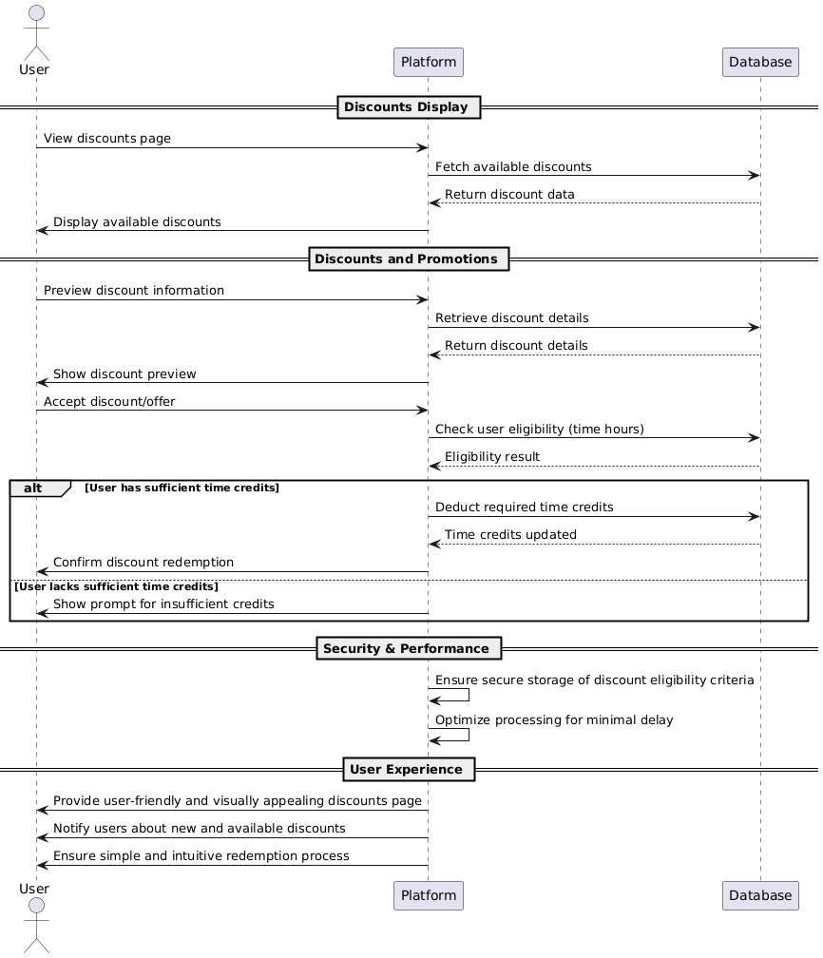
Sequence diagram for Discounts system 1

Testing
Req. Code | Req. Description | Test ID | Test Case Description | Expected Result | Status
DMS-F-1.0 | The users should be able to view all the available discounts on the “discounts” page. | TC-001 | Ensure users can view all available discounts on the discounts page | Users should be able to see a list of all available discounts on the page | Pending
DMS-F-1.1 | The users shall be able to preview discount information. | TC-002 | Verify that users can preview information about discounts | Users should be able to click and view detailed discount information | Pending
DMS-F-1.2 | Users should be allowed to accept the discounts and offers. | TC-003 | Ensure users can accept discounts and offers | Users should be able to click an accept button to confirm the discount | Pending
DMS-F-1.3 | The system shall provide discounts at partner businesses based on the user's time hours. | TC-004 | Verify that discounts are provided based on user's time hours | Discounts should be calculated based on the time hours a user has | Pending
DMS-F-1.4 | The system shall track eligibility for discounts based on time hours. | TC-005 | Ensure the system tracks eligibility for discounts based on time hours | System should calculate and track user eligibility for discounts based on hours | Pending
DMS-F-1.5 | A prompt should be given if the user does not have sufficient time credits. | TC-006 | Ensure prompt is displayed if the user lacks sufficient time credits | A prompt should appear informing the user about insufficient credits | Pending
DMS-NF-1.6 | The system should ensure that discount eligibility criteria are stored securely. | TC-007 | Verify that discount eligibility criteria are securely stored | Eligibility criteria should be encrypted and stored securely | Pending
DMS-NF-1.7 | The system should process discount requests efficiently to minimize delays. | TC-008 | Ensure efficient processing of discount requests | Discount requests should be processed quickly and with minimal delay | Pending
DMS-UR-1.8 | The discounts page should be user-friendly and visually appealing. | TC-009 | Ensure the discounts page is user-friendly and visually appealing | The discounts page should have a clean intuitive design with easy navigation | Success
DMS-UR-1.9 | Users should receive clear and timely notifications about available discounts. | TC-010 | Ensure users receive notifications about available discounts | Users should get clear notifications promptly when new discounts are available | Pending
DMS-UR-1.10 | The discount redemption process should be simple and intuitive. | TC-011 | Verify the simplicity and intuitiveness of the discount redemption process | The process should be straightforward with clear steps for redemption | Pending

Chat System

Software Requirements Specification:
Req. Code | Req. Description | Use Case
HRF-CS- 1.0 | The system should allow chat functionality to allow clients and service providers to chat with each other. | Message Sending
HRF-CS- 1.1 | The chat system shall support text-based conversations. | Message Sending
HRF-CS- 1.2 | Messages shall display sender information. | Message Display
HRF-CS- 1.3 | Conversations shall be shown in chronological order. | Message Display
HRF-CS- 1.4 | Users shall receive real-time notifications for new messages. | Message Notification
HRF-CS- 1.5 | Message history shall be stored for future reference. | Message Persistence
CHAT-F-1.6 | Users shall be able to search for messages within their chat history. | Message Retrieval
CHAT-F-1.7 | Chat shall be accessible from user profiles | Chat Initiation
CHAT-F-1.8 | Users shall be able to delete their messages. | Message Management

Use case diagram

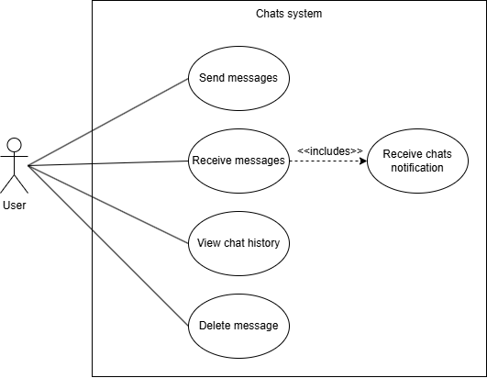
Use case diagram for chats system 1

Sequence diagram
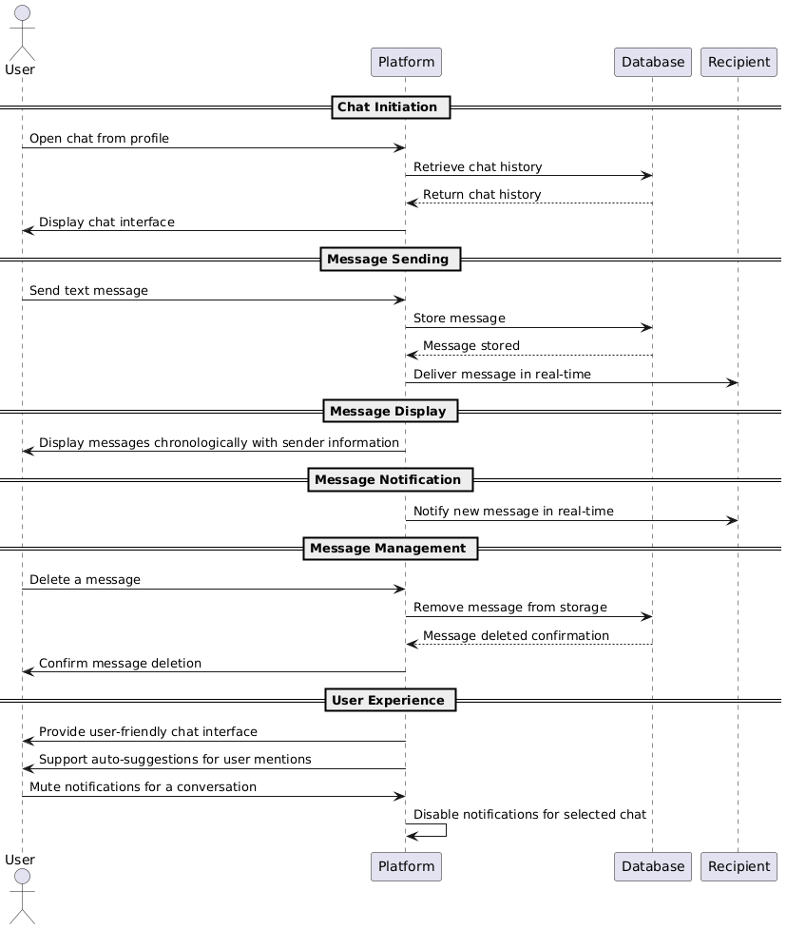
Sequence diagram for chats system 1

Testing
Req. Code | Req. Description | Test ID | Test Case Description | Expected Result | Status
CS-F-1.0 | The system should allow chat functionality to enable clients and service providers to chat with each other. | TC-001 | Ensure users can send and receive messages in the chat | Users should be able to send and receive messages within the chat | Pending
CS-F-1.1 | The chat system shall support text-based conversations. | TC-002 | Verify that the system supports text-based messages | The system should allow users to send and receive text-based messages | Pending
CS-F-1.2 | Messages shall display sender information. | TC-003 | Ensure that messages display the sender's information | Messages should show the sender’s name or profile information | Pending
CS-F-1.3 | Conversations shall be shown in chronological order. | TC-004 | Verify that conversations are displayed in the correct order | Messages should appear in chronological order with the newest message at the bottom | Pending
CS-F-1.4 | Users shall receive real-time notifications for new messages. | TC-005 | Ensure users receive notifications for new messages | Users should get immediate notifications when new messages are received | Pending
CS-F-1.5 | Message history shall be stored for future reference. | TC-006 | Verify that the system stores message history | Messages should be saved and retrievable from past conversations | Pending
CS-F-1.6 | Users shall be able to search for messages within their chat history. | TC-007 | Ensure users can search their chat history | Users should be able to search messages by keywords or other criteria | Pending
CS-F-1.7 | Chat shall be accessible from user profiles. | TC-008 | Verify that chat can be accessed from user profiles | Users should be able to open and access the chat from their profile page | Pending
CS-F-1.8 | Users shall be able to delete their messages. | TC-009 | Ensure users can delete their messages | Users should be able to delete individual messages within a conversation | Pending
CS-NF-1.9 | The system should encrypt messages to ensure data privacy. | TC-010 | Ensure that messages are encrypted | Messages should be encrypted during transmission to protect privacy | Pending
CS-NF-1.10 | The chat feature should have minimal latency for real-time interaction. | TC-011 | Verify the latency of the chat system | The chat system should have minimal delay providing near-instant communication | Pending
CS-NF-1.11 | The system should handle a large number of concurrent chats without performance issues. | TC-012 | Ensure the system supports multiple concurrent chats | The system should maintain performance even with a large number of active users chatting simultaneously | Pending
CS-UR-1.12 | The chat interface should be user-friendly and visually clear. | TC-013 | Verify the clarity and ease of use of the chat interface | The interface should be intuitive and easy to navigate | Pending
CS-UR-1.13 | The message input field should support auto-suggestions for user mentions. | TC-014 | Ensure the message input field supports auto-suggestions | When typing the system should suggest user names for mentions | Pending
CS-UR-1.14 | Users should be able to mute notifications. | TC-015 | Ensure users can mute notifications for specific chats | Users should be able to mute notifications. | Pending

MongoDB Schema Design Diagram

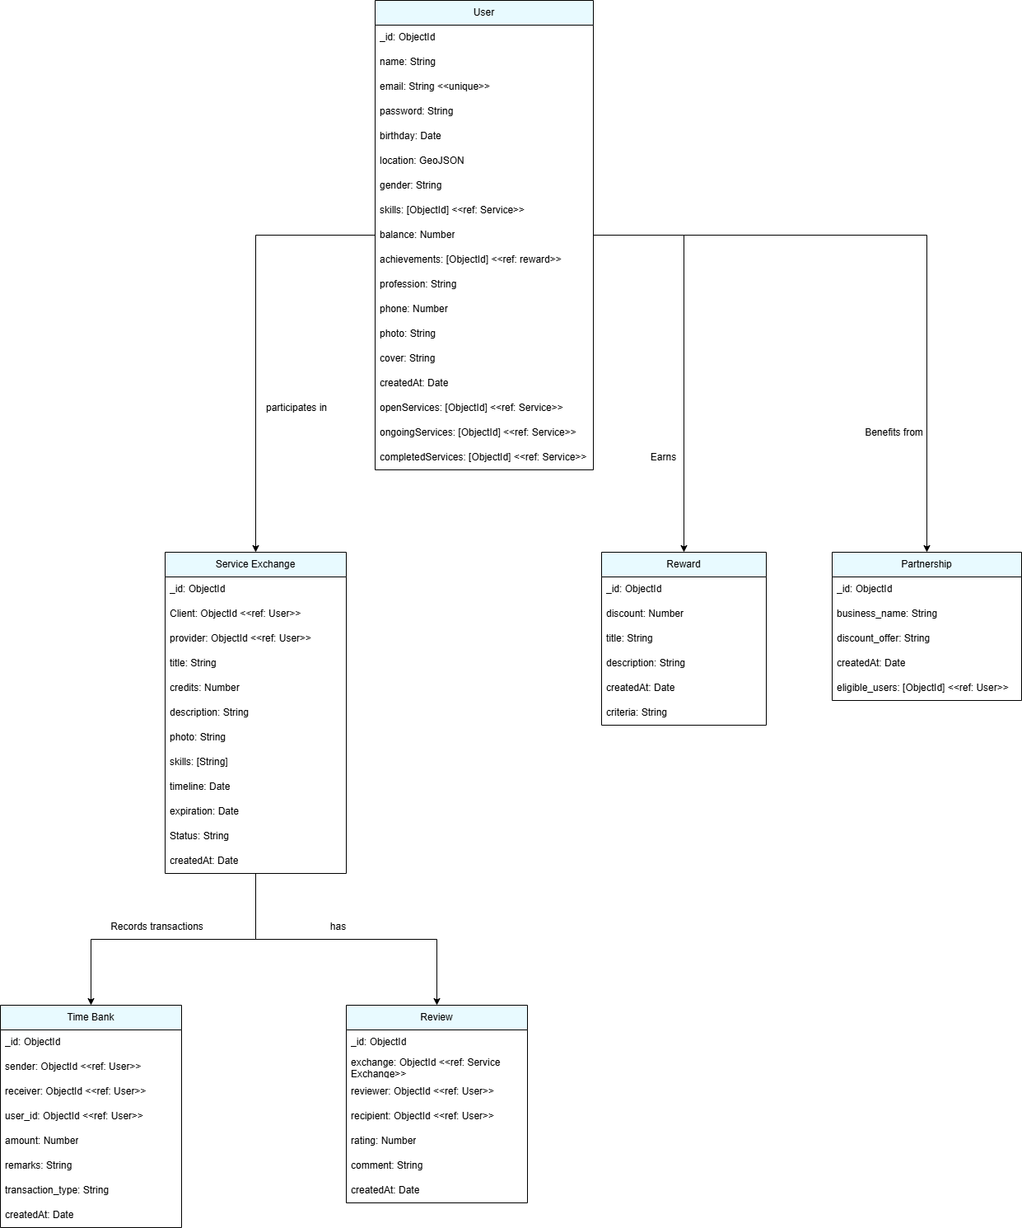
MongoDB Schema Design Diagram 1

Gantt
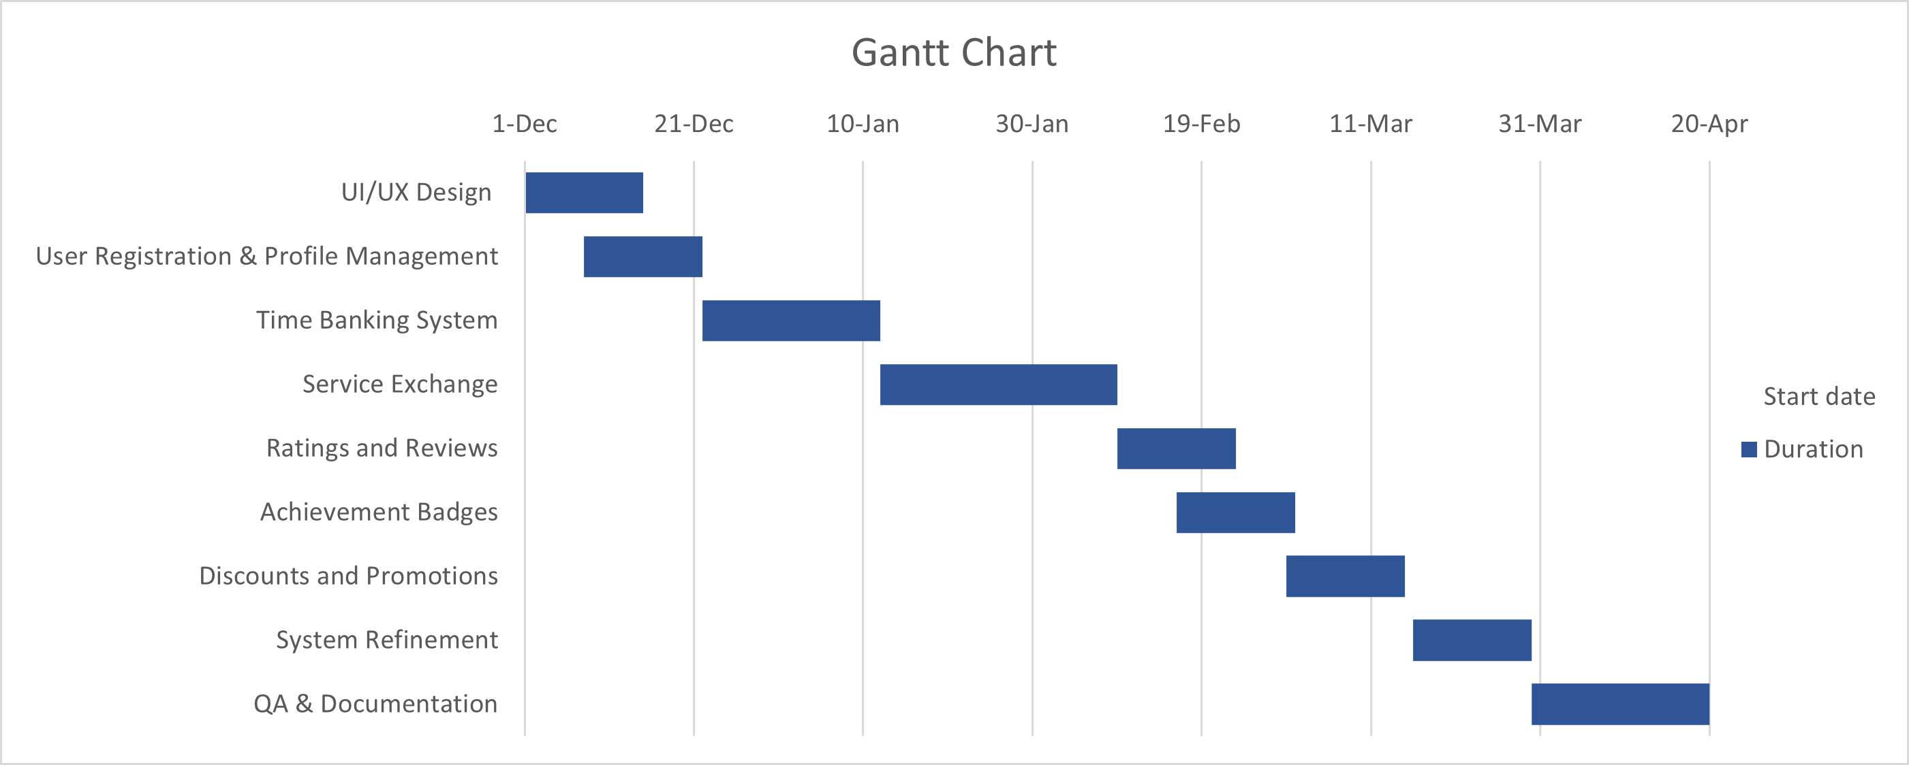
Gantt chart 1

Wireframes
